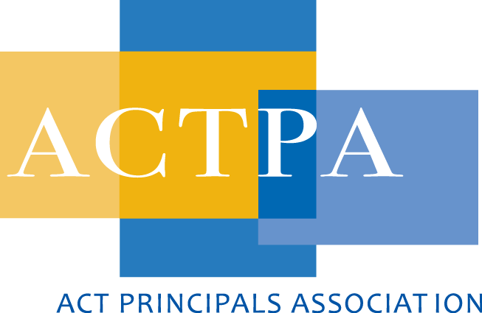
International Confederation of Principals (ICP)

12th Convention – Helsinki Finland

3 – 6 August 2015

HIDDEN FEATURES OF SUCCESSFUL EDUCATION SYSTEMS
Keynote Presentation – Pasi Sahlberg

Pasi started by asking the audience to contemplate the question “To which countries would we go to find out about the ‘next things to do’ in education if it was before the year 2000?” Most in the audience had the same response – America and/or England. Then PISA and TIMSS results were published for OECD countries and so, Finland became the country we all wanted to know about!

Sahlberg contends that we (education policy-makers) are simply continuing to make the same mistakes in education by copying the same flawed ideas in education from other countries.

He asked the audience “To which countries would you go to find innovative ideas about education; if you were doing so in the year 2000?" After the almost unanimous response of “The US or the UK!” he asked what happened after 2000, when the first PISA results table emerged; with Finland on top in most areas tested in PISA. Or what happened when the 2003 results were published with the Finns on top in Maths and in 2006 in Science!

Yet, in the past decade, many countries continue the trend of copying largely disproved policy approaches from the major advanced economies of the USA & the UK. So then we ask why?

Sahlberg outlined the two global change forces active in our current context and he described them in terms of a question together with the characteristics evident in education systems: these are;
Why some education systems don't improve? - Competition, Standardisation, Test-based accountability, De-professionalisation, School Choice (aptly named ‘GERM - global education reform movement’).
What makes some education systems successful? - Collaboration, Creativity, Trust-based responsibility, Professionalism, Equity!

…and in Australia’s case - Equity is a problem that perhaps hinders our own performance in international measurement; not to mention the factors within the Germ approach to policy.

EQUITY!

Successful systems have elevated EQUITY to be a fundamental in the system, or even in the school!
(See PowerPoint attached for graphing of Equity c.f. Achievement based on PISA results.) He identified that the “Highest performing education systems are those that combine excellence with equity.”

EQUITY = ACHIEVEMENT (not a cause and effect but extremely strong relationship!!) and the fundamentals of an equitable system as found in the Finnish education system are:
- Fair school funding
- Early childhood education
- Preventive special education
- School health and wellbeing (basic health services embedded in school system)
- Whole child approach - cultivate the release and improvement of their individual talents

Gender Equality - why it matters?

Sahlberg presented some interesting facts around the percentages of women in Parliament and the outcomes for motherhood and success of students (see PowerPoint). He also highlighted the Australian Government (the Abbot Government of the time) with a single woman in the Cabinet and a male as the Minister for Women (Abbot). He clearly was identifying the countries whose rise up the international performance tables had serious gender balance policies in place at all levels of public and private governance and enterprise and those with less equitable distributions are those countries that seem to be sliding down the rankings. He stated: “Better gender equality helps in building consensus and thereby adopting education and social policies that invest more heavily on wellbeing and holistic development of children at home and in school.” He suggested that the GERM approach to system improvement was a very masculine approach while the elements of collaboration, creativity, trust-based responsibility, leader professionalism and equity are a much more feminine power base.

Sahlberg also highlighted the fact that the children must play! Sitting inside is the new Smoking he contends; with 7 to 8 hours a day in a seat being comparable to smoking a pack of cigarettes a day, in terms of impact upon a person’s health. Hence, the Finnish system - see typical Finnish 4th Grade timetable in PowerPoint – has many places during the school day for play; with students directed to go outside to play in both winter and summer.

The future!!!

What should/could we do in terms of our education system? Should we continue ‘Doing the wrong thing righter’?? Or is it better to ‘Fix the old?’ or even perhaps, ‘Design a new’??? Sahlberg noted the ‘industrial model c.f. a new way’ conundrum that is expressively addressed in Sir Ken Robinson’s new book, Creative Schools.

"School should enable children to understand the world around them and the talents within them."

See his Presentation here
http://pasisahlberg.com/wp-content/uploads/2013/07/ICP-Talk-2015.pdf?utm_content=buffer6493f&utm_medium=social&utm_source=twitter.com&utm_campaign=buffer

